ANDROID APPLICATION FOR SECURITY OF SENIOR CITIZENS
A Major Project Report
Submitted To

Chhattisgarh Swami Vivekanand Technical University
Bhilai, India
For
The Award of Degree
of
Bachelor of Technology
in
Computer Science & Engineering
By

Geetika Malewar  Roll No.-303302219037  En. No.-BH3720  Semester 7th (CSE) | Mayurakshi Singh  Roll No.- 303302219061  En. No.-BH3744  Semester 7th (CSE)

Under the Guidance of
Mr. Anand Tamrakar
Asst. Professor
Department of Computer Science & Engineering
S.S.I.P.M.T, Raipur

________________________________________________________________

Department of Computer Science & Engineering
Shri Shankaracharya Institute of Professional Management & Technology Raipur (C.G.)

SESSION 2022-23

DECLARATION BY THE CANDIDATE

I the undersigned solemnly declare that the report of the SEPM Project work entitled ANDROID APPLICATION FOR SECURITY OF SENIOR CITIZENS, is based on my own work carried out during the course of my study under the supervision of Mr. Anand Tamrakar.

I assert that the statements made, and conclusions drawn are an outcome of the project work. I further declare that to the best of my knowledge and belief that the report does not contain any part of any work which has been submitted for the award of any other degree/diploma/certificate in this University/deemed University of India or any other country.

1. 2 .
(Signature of Candidate 1)  Name: Geetika Malewar  Roll No.:30330229037  En. No.: BH3702  Semester: 7th |  | (Signature of Candidate 2)  Name: Mayurakshi Singh  Roll No.: 303302219061  En. No.: BH3744  Semester: 7th

CERTIFICATE BY THE SUPERVISOR

This is to certify that the SEPM project report of entitled ANDROID APPLICATION FOR SECURITY OF SENIOR CITIZENS, is a record of Bonafide research work/Project work carried out by Geetika Malewar bearing Roll No.: 303302219037 & Enrollment No.:BH3720 and Mayurakshi Singh bearing Roll No.: 303302219061 & Enrollment No.:BH3744 under my guidance and supervision for the award of Degree of Bachelor of Technology of Chhattisgarh Swami Vivekanand Technical University, Bhilai (C.G.), India.

To the best of my knowledge and belief the thesis embodies the work of the candidate him/herself, Has duly been completed, Fulfils the requirement of the Ordinance relating to the B.Tech degree of the University .Is up to the desired standard both in respect of contents and language for being referred to the examiners.

______________________

(Signature of the Supervisor)

Mr. Anand Tamrakar
Asst. Professor, Dept of C.S.E
S.S.I.P.M.T, Raipur (C.G.)

Forwarded to
Chhattisgarh Swami Vivekanand Technical University, Bhilai

_______________________________  (Signature of HOD)  Dept. of Computer Science & Engineering  S.S.I.P.M.T, Raipur, C.G | _______________________________  (Signature of the Principal)  Dr. Alok Kumar Jain  S.S.I.P.M.T, Raipur, C.G

CERTIFICATE BY THE EXAMINERS

The Thesis/Project entitled ANDROID APPLICATION FOR SECURITY OF SENIOR CITIZENS Submitted by Geetika Malewar bearing Roll No.: 303302219037 & Enrollment No.: BH3720 and Mayurakshi Singh bearing Roll No.: 303302219061 & Enrollment No.: BH3744 has been examined by the undersigned as a part of the examination and is hereby recommended for the award of the degree of Bachelor of Technology of Chhattisgarh Swami Vivekanand Technical University, Bhilai.

Internal Examiner  Date: |  | External Examiner  Date:

ACKNOWLEDGEMENT

Working for this project has been a great experience for us. There were moments of anxiety, when we could not solve a problem for the several days. But we have enjoyed every bit of process and are thankful to all people associated with us during this period we convey our sincere thanks to our project guide Mr. Anand Tamrakar (Assistant Professor, Dept. of Computer Science & Technology, Shri Shankaracharya Institute of Professional Management & Technology, Raipur) for providing us all sorts of facilities. Her support and guidance helped us to carry out the project. We owe a deep gratitude for her constant advice, support, cooperation & encouragement throughout the project. we would also like to express our deep gratitude to respected Dr. J P Patra (Head of Department) for his ever helping and support. We also pay special thanks for his helpful solution and comments enriched by his experience, which improved our ideas for betterment of the project. We would also like to express our deep gratitude to respected Dr. Alok Kumar Jain (Principal) and college management for providing an educational ambience. It will be our pleasure to acknowledge, utmost cooperation and valuable suggestions from time to time given by our staff members of our department, to whom we owe our entire computer knowledge and also, we would like to thank all those persons who have directly or indirectly helped us by providing books and computer peripherals and other necessary amenities which helped us in the development of this project which would otherwise have not been possible.
ACKNOWLEDGEMENT –AICTE IDEA Lab

We have taken efforts in this project. However, it would not have been possible without the kind support and help of AICTE-IDEA Lab at SSIPMT, Raipur. We would like to extend our sincere thanks to all the gurus, mentors and support staff of Idea lab.

LIST OF ABBREVIATIONS

BT | Burst Time
RR | Round Robin
FCFS | First Come First Serve
Java SE | Java Standard Edition
Java EE | Java Enterprise Edition
JVM | Java Virtual Machine
JIT | Just In Time Compiler
JDK | Java Development Kit
JRE | Java Runtime Environment
CDDL | Common Development and Distribution License
SDLC | System Development Life Cycle

LIST OF FIGURES
Figure No. | Description | Page No.
Figure 1 | Waterfall Model | 15
Figure 2 | Workflow 1.0 | 17
Figure 3 | SDLC | 18
Figure 4 | Data flow diagram | 22
Figure 5 | Workflow 2.0 | 24
Figure 6 | Use case diagram | 26
Figure 7 | ER diagram | 28

ABSTRACT
The most pressing issue to far has been how to ensure the safety of senior citizens. Additionally, among older persons, falls, burns, poisoning, and car accidents are the most frequent safety issues. These days, the majority of older citizens carry their smartphone about, thus it is essential to have at least one personal safety app installed.

Anyone who has loaded this user-friendly software on their smartphone can access it.

Our goal is to make it as quick and easy as possible for you to contact the local aid. In this system, the user must enter three contact numbers; in the event of an emergency, the system will call one of the numbers entered into the system and send an SMS with the user's location once the user moves the phone up and down three times.

Keywords: SOS Application, Senior Citizen, Google Map API Technique, Djkstra

TABLE OF CONTENTS
 | Page No.
DECLARATION BY CANDIDATE | I
CERTIFICATE BY SUPERVISOR | II
CERTIFICATE BY EXAMINERS | III
ACKNOWLEDGEMENT | IV
ACKNOWLEDGEMENT TO AICTE IDEA LAB | V
LIST OF FIGURES | VI
LIST OF ABBREVIATIONS | VII
ABSTRACT | VIII

Chapter |  | Page No.
Chapter 1 | Introduction | 1-2
Chapter 2 | Literature Review | 3-4
 | 2.1 Problem Identification | 3
 | 2.2 Literature Survey | 3-4
Chapter 3 | Methodology | 5-18
 | 3.1 Experimental Setup | 5-7
 | 3.2 Database Used | 7-10
 | 3.3 Data flow diagram | 11-13
 | 3.4 Workflow diagram | 14-15
 | 3.5 Use Case Diagram | 16-17
 | 3.6 ER diagram | 18
Chapter 4 | Result | 18-21
 | 4.1 Snapshot with Description
Chapter 5 | Conclusion | 22-23
 | Reference | 24
 | Paper Publication with Certificate | 25-28

Chapter I
Introduction About Project

Senior citizen’s safety is a big concern which has been an important topic till date. Few issues faced by them includes lack of shelter, fear, depression, senility, isolation, boredom, non-productivity, and financial incapacity. Most of the people of this age group, till this day are being subjected to distress and vulnerability. Although the government is taking necessary measures for their safety, still, there are measures that can help them to stay safe.
Most of the senior citizens these days carry their smartphone with them, so it is necessary to have at least one the personal safety apps installed. This is user-friendly application that can be accessed by anyone who has installed it in their smart phones. Our intention is to provide you with fastest and simplest way to contact your nearest help.
It’s difficult for Senior Citizens to use modern smartphones. How about we install fewer apps and increase the font size? But then, what’s the point of having a smartphone, if it’s not smart enough. Right? A better solution is to install apps that are made especially for older people.
One-fifth of the world's population, including a third of the impoverished and an eighth of the elderly, resides in India. As a result, the world is interested in its approach to delivering social security to the elderly. Senior citizen security is meant to help persons who, for temporary or long-term reasons, are unable to work and support themselves. In more developed countries, social security is a fundamental component of the level of living (MDCs).However, the amount of vulnerability in the Less Developed Countries (LDCs) is significantly greater than the risks typically addressed by the social security systems that are present in the MDCs because of chronic unemployment and acute deprivation that are inherent in the social structures. An important restriction in LDCs is the economic viability providing social security at a comparable level.

On this world, there are about 600 million persons above the age of 60. This number is anticipated to increase fourfold to two billion by the year 2050. a report from Help Age and the United Nations Population Fund (UNFPA)
India currently has about 100 million older individuals, and by the year 2050, that figure is projected to rise to 323 million, or 20 percent of the country's whole population. Ages that are close to or have passed the typical human lifespan are considered elderly or old. The accurate definition of old age is impossible because the term has different connotations among social groups.

According to the Maintenance and Welfare of Parents and Senior Citizens Act of 2007, a senior citizen is any Indian citizen who is 60 years of age or older. The biological truth of ageing is essentially outside of our control. However, it is also dependent on how society conceptualises ageing. In the developed world, the passage of time is crucial. In the industrialised world, retirement is generally considered to begin at age 60 or 65, which also marks the start of old age. In contrast, some socially constructed definitions of age are more prevalent in emerging nations, such as the roles that are given to the elderly.

Senior citizens have trouble using modern devices. What if we reduce the number of programmes we install and enlarge the font? But if a smartphone isn't smart enough, what good is having one? Right? Installing apps that are created specifically for elderly users is a better approach.

And that's how Senior Citizen Security, or SCS, operates. At this point, Senior Citizens can access a life-saving piece of technology. The best and safest tool against the corrupt minds that exist in society is these apps, which can provide an unseen defence. This programme gives older citizens an easy and comfortable method to live their lives by offering SOS, Healthcare, Safe Stays, and other functions.

Chapter II
Literature Review
2.1 Problem Identification

Senior Citizens safety Apps! A life-saving piece of technology women can get hold of at this juncture of time. These apps can offer an invisible guard and can be the best and safest tool available against the crooked minds out there in society.

There are approximately 600 million people over the age of 60 living on this planet. By the year 2050, this figure is expected to quadruple to two billion. A joint report by the United Nations Population Fund (UNFPA) and Help Age International said India has around 100 million older adults and the number is expected to increase to 323 million by 2050, constituting 20 percent of the total population.
Elderly or old age consists of ages nearing or surpassing the average lifespan of human beings. The boundary of old age cannot be defined exactly because it does not have the same meaning in all societies. In the Maintenance and Welfare of Parents and Senior Citizens Act, 2007, senior citizen means any person being a citizen of India, who has attained the age of 60 years or above.
The ageing process is a biological reality which is largely beyond human control. However, it is also subject to the way in which society makes sense of old age. In the developed world chronological time plays a vital role. The age of 60 or 65 in the developed world is considered the age of retirement and is an indication of the beginning of old age. In contrast in the developing world, other socially generated meanings of age are more prominent such as the roles assigned to older people.
In the case of safety apps, quality has of utmost important than any other. Proper testing has to be done to make sure that these apps do not have any kind of flaws. Since people rely on this app for safety, it’s the trust that has to be valued more than anything else.

The algorithm is chosen to give the system the capacity to deal with a variety of emergency situations. To ensure good system performance and to satisfy user requests, we combined the existing FCFS queue (First Come, First Served) scheduling approach with Dijkstra's algorithm. Dijkstra's approach, in contrast, looks for the quickest route between a user-selected source and a destination. In the event of heavy traffic, a different route with a different duration is chosen.
In this application, the Dijkstra algorithm is utilised to assist police and ambulances in locating individuals who require immediate medical attention when available resources are insufficient. The Dijkstra algorithm is used by the Google Maps API to direct a guiding GPS device as we travel to our destination utilising various modes of transportation, providing estimates of traffic conditions and travel times.
The end user, the receiver, and the system administrator are the three key users who operate SCS.
The use case diagram for the programme, which displays the actions and connections made by each system user, is provided below. The figure shows how functionalities are available to the user, receiver, and administrator.


2.2 LITERATURE SURVEY

A. An Android App Rapid SoS+

A power full emergency, One touch SOS alert is provided by the programme, but what's more intriguing is that it may dial 9-1-1 on behalf of a loved one and communicate that person's current position and other relevant information to the nearest dispatch centre. So, if necessary, their request can be sent (RapidSOS, n.d.) In addition, it allows users to check in when they reach at their location and use GPS to make sure their family members are safe.

- An Android Application for Senior Citizen Emergency
bSafe is a mobile application for Android that offers the user multiple options; specifically, four services are offered: bSafe Alarm, Follow me, Timer Alarm, and Fake call. The first one is designed for sending an SMS that includes the user's location; however, in addition to the location, audio and video data may also be sent. An automatic recording is started when this option is selected, and the recorded information is forwarded to the designated number or numbers. In this application, the user can create a friend cycle with as many numbers as desired, and these numbers can be changed as often as the user likes. The second choice enables real-time tracking of the user's location on the map. In the third option, the user can specify when he expects to arrive at a particular area. If he does not arrive within the specified time, an SMS message containing his current location will be sent. The final but not least choice offers a face-to-face call.

C. Emergency alarm security system

A model built on SySML and a process to ensure the safe and secure design of cyber-physical systems. The Generic Systems Engineering analysis is used to offer a system specification at first, and SySML notation is used to express a safety scenario. Identification of potential assault scenarios is made possible by the combination of these two. To create security structures with communication and encryption restrictions, a qualitative evaluation of the attack scenario probability of occurrence and success is used.

D. An Android Security App - SaveME 999

The Royal Malaysian Police (PDRM) and Telekom Malaysia (TM) collaborated on this application, which is available to Malaysian nationals and enables victims to call for assistance by pressing a panic button. If the panic button is pressed, MERS 999 Response Centre (MERS 999 RC) will get the victim's details and the victim's present position. If there is any further information, it can be included with the emergency message and transmitted to MERS 999 RC (thecinnaboy, 2016). With location detection, users can call helplines to obtain information and specifics on local emergencies.

Chapter III
METHODOLOGY
3.1 EXPERIMENTAL SETUP
Software plays a vital role in the development of any system. No matter in which language does the application has been developed. Software is that important part in any application that gives immense support in the development of any system. Software is a set of programs or coding that has been made for the better and easy performance of the computer. In our project we have also used different software for developing it in an efficient manner. In this system, we have used software like windows, android studio, etc.

Window is a part of the graphical user interface (GUI). It is used by the computer to interact with further application and software that is to be used.
The various steps of requirement analysis are shown in fig:
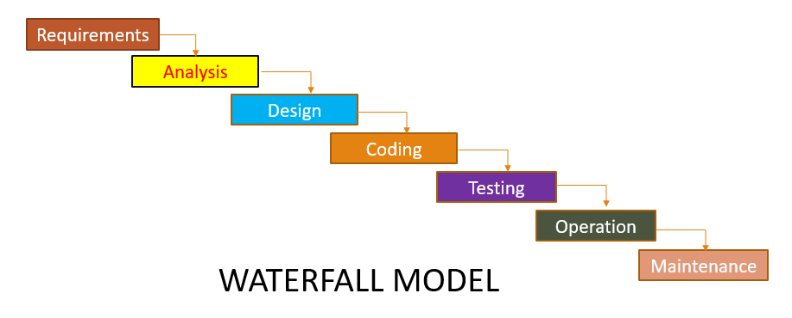
Fig.1
(i) Draw the context diagram: The context diagram is a simple model that defines the boundaries and interfaces of the proposed systems with the external world. It identifies the entities outside the proposed system that interact with the system. The context diagram of student result management system is given below:
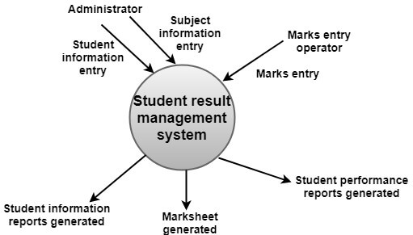
Fig.2

(ii) Development of a Prototype (optional): One effective way to find out what the customer wants is to construct a prototype, something that looks and preferably acts as part of the system they say they want.
We can use their feedback to modify the prototype until the customer is satisfied continuously. Hence, the prototype helps the client to visualize the proposed system and increase the understanding of the requirements. When developers and users are not sure about some of the elements, a prototype may help both the parties to take a final decision.
Some projects are developed for the general market. In such cases, the prototype should be shown to some representative sample of the population of potential purchasers. Even though a person who tries out a prototype may not buy the final system, but their feedback may allow us to make the product more attractive to others.
The prototype should be built quickly and at a relatively low cost. Hence it will always have limitations and would not be acceptable in the final system. This is an optional activity.
(iii) Model the requirements: This process usually consists of various graphical representations of the functions, data entities, external entities, and the relationships between them. The graphical view may help to find incorrect, inconsistent, missing, and superfluous requirements. Such models include the Data Flow diagram, Entity-Relationship diagram, Data Dictionaries, State-transition diagrams, etc.

3.2 DATABASE USED
The Waterfall Model was the first Process Model to be introduced. It is also referred to as a linear-sequential life cycle model. It is very simple to understand and use. In a waterfall model, each phase must be completed before the next phase can begin and there is no overlapping in the phases.
The Waterfall model is the earliest SDLC approach that was used for software development.
The waterfall Model illustrates the software development process in a linear sequential flow. This means that any phase in the development process begins only if the previous phase is complete. In this waterfall model, the phases do not overlap.

Waterfall Model - Design
Waterfall approach was first SDLC Model to be used widely in Software Engineering to ensure success of the project. In "The Waterfall" approach, the whole process of software development is divided into separate phases. In this Waterfall model, typically, the outcome of one phase acts as the input for the next phase sequentially.
The following illustration is a representation of the different phases of theWaterfall Model.
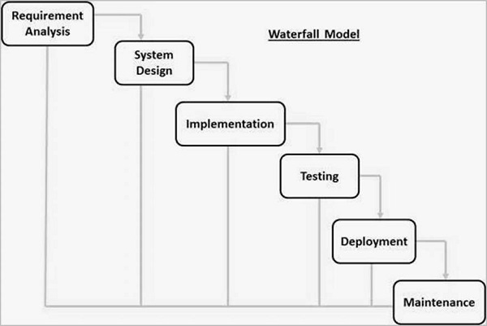
Fig.3
The application SCS (Senior Citizen Security) is created utilising the IDE Android Studio and the backend programming language Java. It was created with an API level objective of 26 and a minimum of 17 for the Android operating system. The android smartphone is fully functional and has the application installed.
Senior folks' protection in emergency scenarios is the major focus of this Android application. Senior citizens around the world are therefore the primary end consumers.

The android application's planned architecture is displayed. Activity, service, and broadcast receiver must all be combined properly to ensure that the offered solution operates smoothly. A window is created by an activity to place UI (user interface) elements when the user interacts with it. Multiple activities can be included in an Android application, allowing numerous screens to communicate with one another. In the suggested method, the user requests to start the service that determines current position by sending a request through a view in an activity.

3.3 DATA FLOW DIAGRAM

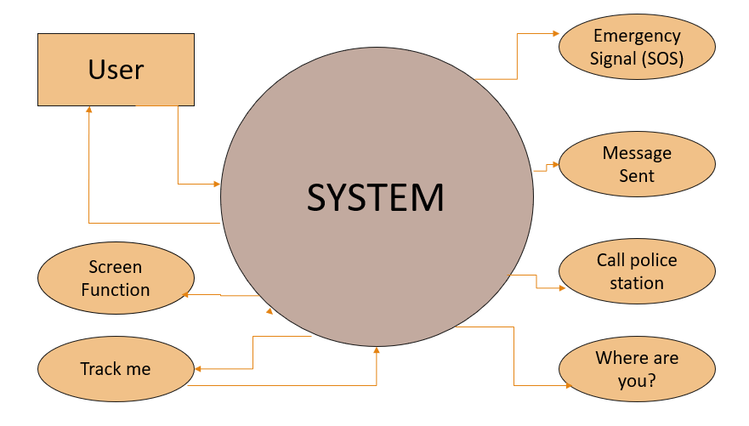
Fig.4

A data flow diagram (DFD) maps out the flow of information for any process or system. It uses defined symbols like rectangles, circles and arrows, plus short text labels, to show data inputs, outputs, storage points and the routes between each destination. Data flowcharts can range from simple, even hand-drawn process overviews, to in-depth, multi-level DFDs that dig progressively deeper into how the data is handled.
That’s why DFDs remain so popular after all these years. While they work well for data flow software and systems, they are less applicable nowadays to visualizing interactive, real-time or database-oriented software or systems.

Five main functions make up this end-user application:

-Emergency button with one click
-Lists of pre-mentioned emergency contacts
-Nearby safe stay
-Legal Rights module and
-Healthcare

3.4 WORK FLOW DIAGRAM
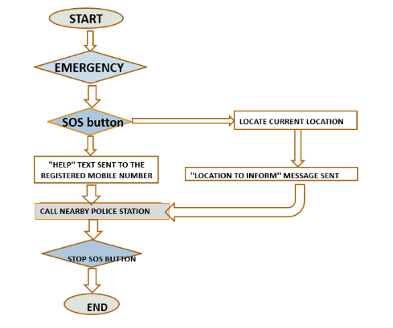
Fig.5
A workflow diagram (also known as a workflow) provides a graphic overview of the business process. Using standardized symbols and shapes, the workflow shows step by step how your work is completed from start to finish. It also shows who is responsible for work at what point in the process. Designing a workflow involves first conducting a thorough workflow analysis, which can expose potential weaknesses. A workflow analysis can help you define, standardize and identify critical areas of your process.
The main interface contains a SOS button, which helps the users to take help in any emergency situations. When a user presses the SOS button, the user's current position, a "Help" text message, and the number of a nearby police station are sent. The police will be able to track both the user's location and real-time location using Google Maps and Google navigation APIs. The driver will receive the contact information so that he or she can reach a certain place.

The most widely used service for enhancing location awareness with automatic position tracking, geofencing, and activity detection is Google Location Services API.

The first main feature is EMERGECY CONTACTS which enable the user to to add immediate and contacts of the close ones, which will help in single tap call in case of emergency.

The second feature is SAFE STAY NEAR ME.This is a significant tool because it gives users access to information on hospitals, hotels, and dorms near their present location.

The third and most important feature is LEGAL RIGHTS which will serve the user in gaining knowledge regarding their Basic Rights, which will help them in case of conflicts and malpractices on them, and make them feel confident and secured.

The fourth feature is HEALTHCARE which provides the user, all the locations of nearby healthcare centers/hospitals and its detail to contact them in a go.

3.5 USE CASE Diagram

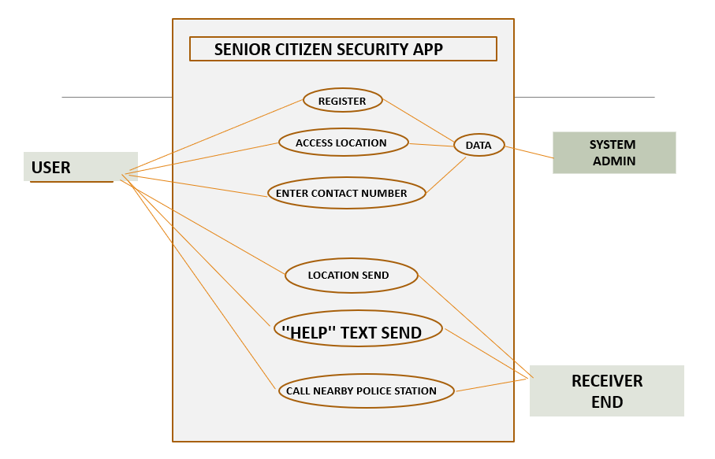
Fig.6
A use case diagram is a graphical depiction of a user's possible interactions with a system. A use case diagram shows various use cases and different types of users the system has and will often be accompanied by other types of diagrams as well. The use cases are represented by either circles or ellipses. The actors are often shown as stick figures.
While a use case itself might drill into a lot of detail about every possibility, a use-case diagram can help provide a higher-level view of the system. It has been said before that "Use case diagrams are the blueprints for your system".
The algorithm is chosen to give the system the capacity to deal with a variety of emergency situations. To ensure good system performance and to satisfy user requests, we combined the existing FCFS queue (First Come, First Served) scheduling approach with Dijkstra's algorithm. Dijkstra's approach, in contrast, looks for the quickest route between a user-selected source and a destination. In the event of heavy traffic, a different route with a different duration is chosen.

In this application, the Dijkstra algorithm is utilised to assist police and ambulances in locating individuals who require immediate medical attention when available resources are insufficient. The Dijkstra algorithm is used by the Google Maps API to direct a guiding GPS device as we travel to our destination utilising various modes of transportation, providing estimates of traffic conditions and travel times.

The end user, the receiver, and the system administrator are the three key users who operate SCS.

3.6 ER DIAGRAM
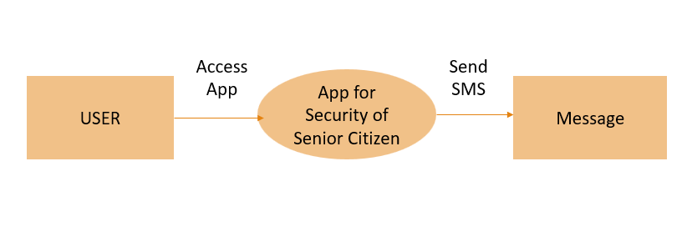
Fig.7
An entity relationship diagram (ERD), also known as an entity relationship model, is a graphical representation that depicts relationships among people, objects, places, concepts or events within an information technology (IT) system.
prime reasons for using the ER Diagram
- Helps you to define terms related to entity relationship modeling
- Provide a preview of how all your tables should connect, what fields are going to be on each table
- Helps to describe entities, attributes, relationships
- ER diagrams are translatable into relational tables which allows you to build databases quickly
- ER diagrams can be used by database designers as a blueprint for implementing data in specific software applications
- The database designer gains a better understanding of the information to be contained in the database with the help of ERP diagram
- ERD Diagram allows you to communicate with the logical structure of the database to users
The use case diagram for the programme, which displays the actions and connections made by each system user, is provided below. The figure shows how functionalities are available to the user, receiver, and administrator.
The system's operation and interface serve as common connecting points for the three actors.

Fig claims that users have the primary obligation for responding to the alarm as quickly as possible. Additionally, the admin user plays a crucial role in managing all requests and generating alarms.

We are using the Google Map API to obtain real-time data from Firebase, where the coordinates of the user and driver locations are saved. Similar to this, the information entered by users into the in-app basic information form, such as mechanic and hospital details, SOS (Save Our Souls) numbers, and details (text and photographs), is also maintained in the Firebase real-time database and local storage, the user's phone number and the Firebase cloud messaging service.

Chapter IV
RESULT
Snapshot
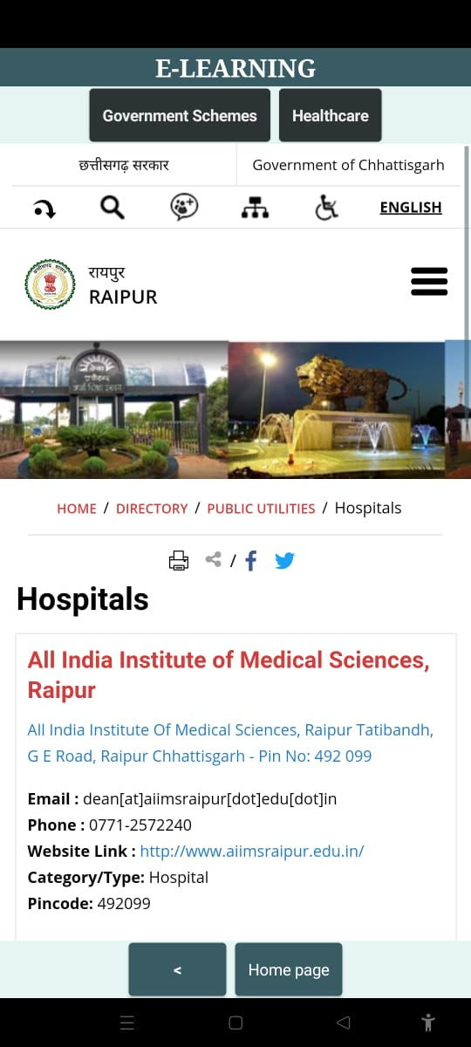

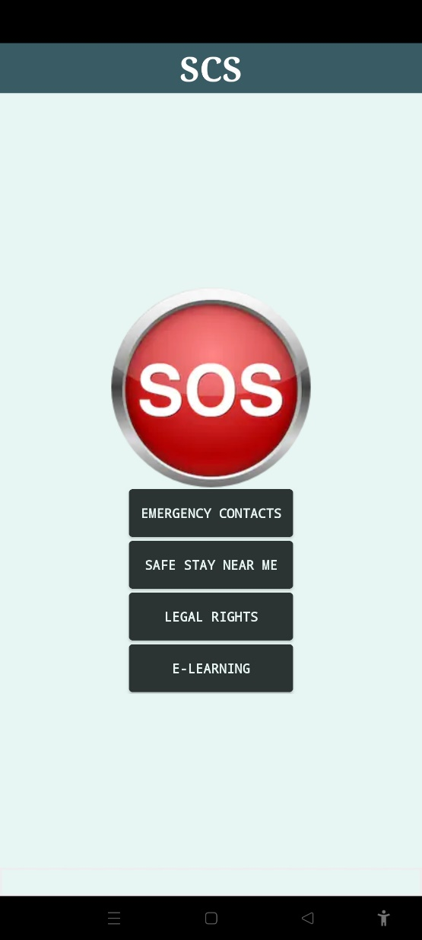

In recent years the family system seems to be embracing and critiquing western living and one such change in family life is that a large number of older adults are joining old age homes. As a result researchers from different fields are showing interest and are doing research on the changes and effects of this transition on older adults.

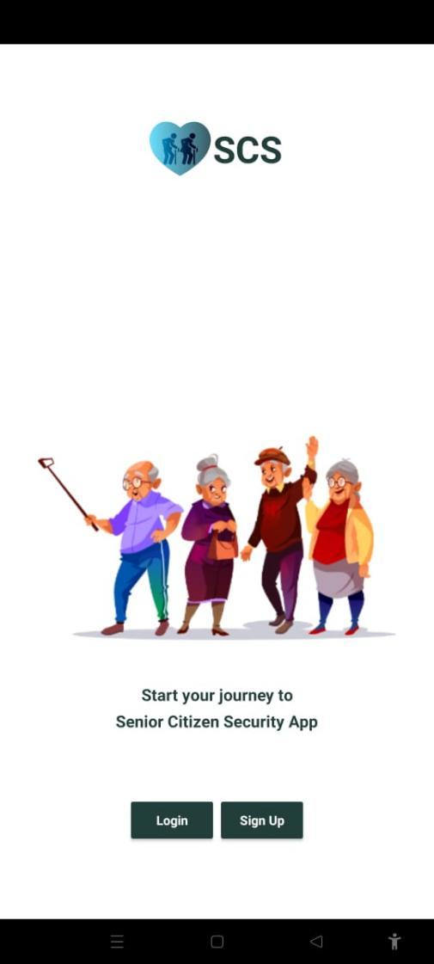

Elderly or old age consists of ages nearing or surpassing the average lifespan of human beings. The boundary of old age cannot be defined exactly because it does not have the same meaning in all societies.
For some, it is the loss of roles that accompany physical decline which is a defining factor for old age. So in contrast to chronological milestones which signify life stages in the developed world, in many developing countries old age begins when active contribution and involvement is no longer possible.

plant.
Our Soil Moisture Indicator senses the moisture levels in the soil upto a depth of 30 cm (1 feet). Soil moisture indicator gives moisture status within 2-3 sec.
Irrigation water management requires timely application of the right amount of water. Competition for water, high pumping costs, and concerns for the environment are making good water management more important.
Moisture in Soil can be tested by many ways like lab method, or tensiometers or with other moisture sensors. But the main advantage with Soil moisture indicator it very easy to use, gives instant results, any one can use.
Measuring soil moisture, detects if there is a water shortage that can reduce yields or if there is excessive water application that can result in water logging or leaching of nitrates below the root zone. Measuring soil moisture also can build an awareness and knowledge of each irrigated field that is invaluable for planning and management

oring soil moisture levels is required for effective irrigation management. Water is the most essential resource on our planet.
A plant cannot grow if it doesn’t have healthy roots, therefore the proper balance of water is vital when growing plants Overwatering will let the roots to growing in waterlogged soil which may die because they cannot absorb the oxygen needed to function normally. The dying roots decay and can’t supply the plants with nutrients and water. At the same time If there is not enough water for a plant, the nutrients it needs cannot travel through the plant.
Our Soil Moisture Indicator senses the moisture levels in the soil upto a depth of 30 cm (1 feet). Soil moisture indicator gives moisture status within 2-3 sec.
Irrigation water management requires timely application of the right amount of water. Competition for water, high pumping costs, and concerns for the environment are making good water management more important.
Moisture in Soil can be tested by many ways like lab method, or tensiometers or with other moisture sensors. But the main advantage with Soil moisture indicator it very easy to use, gives instant results, any one can use.
Measuring soil moisture, detects if there is a water shortage that can reduce yields or if there is excessive water application that can result in water logging or leaching of nitrates below the root zone. Measuring soil moisture also can build an awareness and knowledge of each irrigated field that is invaluable for planning and management

nitoring soil
Monitoring soil moisture levels is required for effective irrigation management. Water is the most essential resource on our planet.
A plant cannot grow if it doesn’t have healthy roots, therefore the proper balance of water is vital when growing plants Overwatering will let the roots to growing in waterlogged soil which may die because they cannot absorb the oxygen needed to function normally. The dying roots decay and can’t supply the plants with nutrients and water. At the same time If there is not enough water for a plant, the nutrients it needs cannot travel through the plant.
Our Soil Moisture Indicator senses the moisture levels in the soil upto a depth of 30 cm (1 feet). Soil moisture indicator gives moisture status within 2-3 sec.
Irrigation water management requires timely application of the right amount of water. Competition for water, high pumping costs, and concerns for the environment are making good water management more important.
Moisture in Soil can be tested by many ways like lab method, or tensiometers or with other moisture sensors. But the main advantage with Soil moisture indicator it very easy to use, gives instant results, any one can use.
Measuring soil moisture, detects if there is a water shortage that can reduce yields or if there is excessive water application that can result in water logging or leaching of nitrates below the root zone. Measuring soil moisture also can build an awareness and knowledge of each irrigated field that is invaluable for planning and management
moisture levels is required for effective irrigation management. Water is the most essential resource on our planet.
A plant cannot grow if it doesn’t have healthy roots, therefore the proper balance of water is vital when growing plants Overwatering will let the roots to growing in waterlogged soil which may die because they cannot absorb the oxygen needed to function normally. The dying roots decay and can’t supply the plants with nutrients and water. At the same time If there is not enough water for a plant, the nutrients it needs cannot travel through the plant.
Our Soil Moisture Indicator senses the moisture levels in the soil upto a depth of 30 cm (1 feet). Soil moisture indicator gives moisture status within 2-3 sec.
Irrigation water management requires timely application of the right amount of water. Competition for water, high pumping costs, and concerns for the environment are making good water management more important.
Moisture in Soil can be tested by many ways like lab method, or tensiometers or with other moisture sensors. But the main advantage with Soil moisture indicator it very easy to use, gives instant results, any one can use.
Measuring soil moisture, detects if there is a water shortage that can reduce yields or if there is excessive water application that can result in water logging or leaching of nitrates below the root zone. Measuring soil moisture also can build an awareness and knowledge of each irrigated field that is invaluable for planning and management

Chapter- V
CONCLUSION
The App will act like a security weapon for women to ensure their safety. This application works on any handheld devices with Android operating system. This application provides rich tools for sending messages to the predetermined contacts, making calls to the nearby police stations which automatically include the exact location of the user.
The main advantage of this app is that it has six different features integrated in a single application. It doesn’t need any internet connection to identify the user’s location. It will ensure the safety of the women to a greater extent because of its six different features. Hence this application will survive long and surely reduces the maximum risk of becoming a victim. This app can be developed with some more features in the future and make it more user friendly.
As far as India is concerned, use of technology for aiding women’s security is important. Today, apps might not play a vital role in security, but its constant use and regular updates as per the need and awareness about security will help the apps see good days in the future.
The rapid growth of the elderly population highlights elder care as an important issue in India. The issues of elder security and well- being are becoming a matter of concern. There is a need to take care of older adults, with a focus on social and mental well-being, economic and social security and elder abuse. Considering all these factors there seems to be a need to understand the experiences of older adults in order to adopt effective mechanisms by which they will be cared for and respected and will be able to live a life with dignity.
Presently, apps work on inputs given by women themselves. Since they are not in a condition to provide inputs at all times, external monitoring and integration of various users on the same app can help provide better results. Integration of SOS facility and GPS can prove beneficial for the users.
For senior citizens, the app will function as a security tool to safeguard their safety. Any handheld device running the Android operating system can use this application. This programme offers a variety of useful options for communicating with specified contacts and calling nearby police stations while automatically providing the user's precise location. They learn to accept and live with the difficulties of their frail and declining physical condition, as well as the loss of control at various levels, such as when they fall, from incontinence, and from the stigma of having to deal with an embarrassing situation, in order to cope efficiently.While older persons strive for maximum independence, they also rely on community care. They fortify their resolve in order to overcome their dread of falling.
This app's key benefit is that it combines four distinct functionalities into a single application. The user's location can be determined without an internet connection. Due to its four various features, it will more thoroughly safeguard the safety of Senior Citizens. Thus, this app will endure for a long time and will undoubtedly lower the chance of being a victim to the lowest possible level. Future development of this app could add more features to make it more user-friendly.
Senior citizens have trouble using modern devices. What if we reduce the number of programmes we install and enlarge the font? But if a smartphone isn't smart enough, what good is having one? Right? Installing apps that are created specifically for elderly users is a better approach.

And that's how Senior Citizen Security, or SCS, operates. At this point, Senior Citizens can access a life-saving piece of technology. The best and safest tool against the corrupt minds that exist in society is these apps, which can provide an unseen defence. This programme gives older citizens an easy and comfortable method to live their lives by offering SOS, Healthcare, Safe Stays, and other functions.

REFERENCES

Book

Mal, B.C. 1995. Introduction to Soil and Water conservation Engineering. Kalyani Publishers, New Delhi.. First Ed. Ch 16, pp 403-406.

Journals

Mal, B. C. 1991. Optimum Spacing of Tubewells in Relation to Channel Losses and Lining. J. ASCE, Irrigation and Drainage Div. 117 (5): 791-799.

Moulick, S and Mal, B. C. 2009.Performance Evaluation of Double Hub Paddle Wheel Aerator. Journal of Environmental Engng, ASCE 135(7): 562-566.

Pandey, A., Chowdary, V.M., Mal, B.C. and Billib, M. 2009. Application of the WEPP Model for Prioritization and Evaluation of Best Management Practices in an Indian Watershed. Hydrological Processes. 23: 2997-3005.

Website:
http://www.gobbeldygook.co.uk

----------------------------------------------------------------------------------------------------------------

Reference links
- https://edusourcecode.com/women-safety-app-android-free-project-source-code/
- https://nevonprojects.com/android-women-safety-app/
- https://youtube.com
- https://Google.com
RESEARCH PAPER PUBLICATION

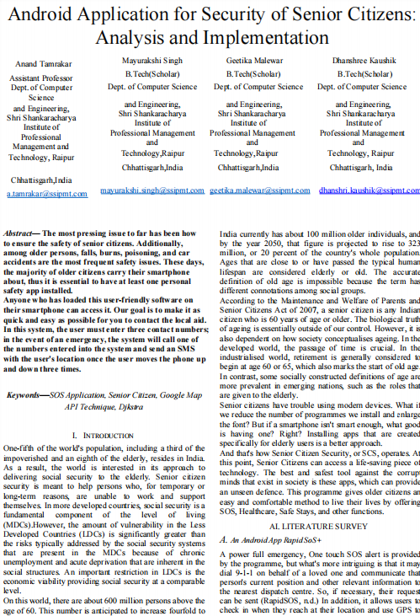

CERTIFICATES

